# C:\Users\ELCOT\Documents\Screenshot_20230422-160413_1.png Project Report Template

# Job Application Tracking System

# 1. INDRODUCTION

## 1.1 Overview

An ATS creates opportunity to automate manual processes, increase visibility into the

Hiring circle for the entire recruiting team, and increase opportunity for communication

Throughout the candidate journey.78%of recruiters using an ATS report that it has

Improved the quality of the candidates they hire.

## 1.1 Purpose

An ATS allows recruiters to match job requisitions to the job-posting sites and the social media channels most appropriate for specific candidates. An ATS also maximizes visibility for internal job boards, while requiring fewer clicks and eliminating barriers for prospective employees.

## 2. Problem Definition & Design Thinking

## 2.1 Empathy Map



## 2.2 Ideation& Brainstroming Map

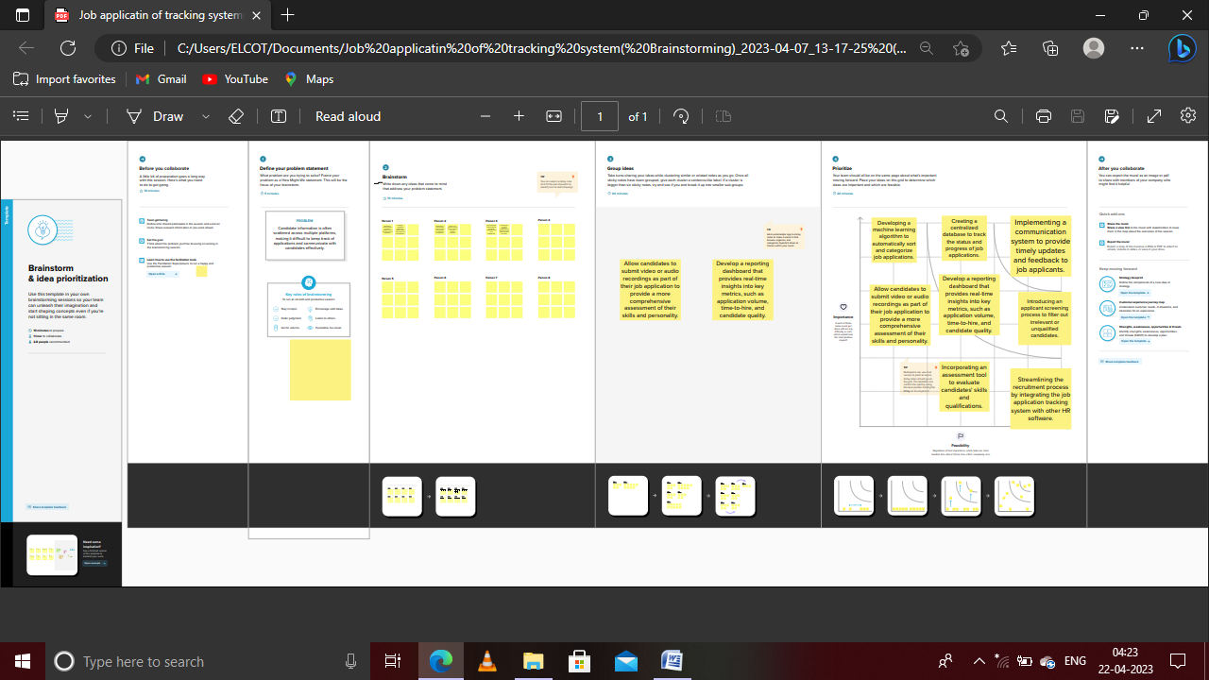

## 3. RESULT

## 3.1 Data model

|  |  |  |
| --- | --- | --- |
| Object Name | Field in the object | |
|  | Field label | Data type |
| New custom object | Recruiter Number | Auto numbers |
| Object Manager | Appointment invitation | Standard Object |
| Department | Amount | Currency |
| Job Numbers | Name | Auto Number |

## 

## 3.2 Activity &screenshot

## Salesforce

Salesforce is your customer success platform, designed to help you sell, service, market,

Creation of Salesforce platform

Go to Developer. Salesforce.com and click on sign up, Ender our details as Name,Email, role,

Company etc. email send to your mail id.

Go to the inbox of the email that you used while singing up. Click on the verify account to

your account.

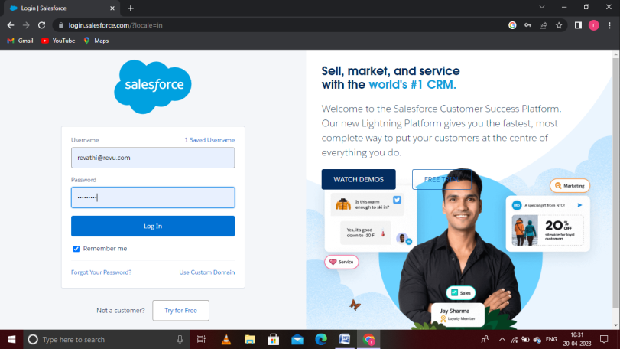

The setup page will appear as below.

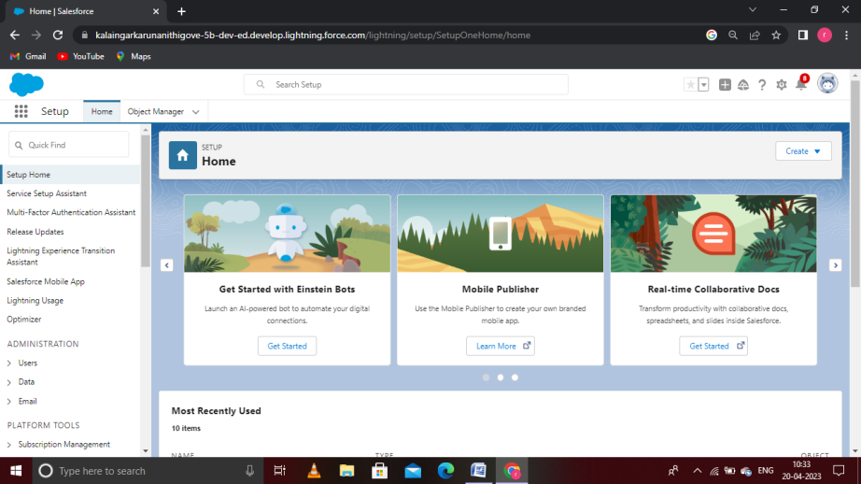

## Object:

## Sales force Object are of two types:

Standard Objects: Standard Object are the kind of Objects that are provided by

salesforce.com such as uses, contracts, reports, dashboards, etc.

Custom Object: Custom Object are those objects that are created by uses. They supply

information that is unique and essential to their Organization. They are the heart of any

application and provide a structure for sharing data.

## Custom object : Recruiters

Navigate to setup to select the object manager and create the object gives the detail like label

name has Recruiters and enter the plural name, record name data type etc., and save it.

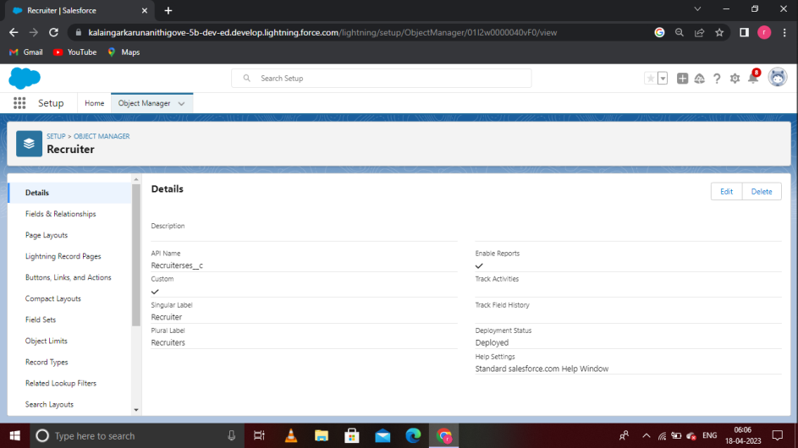

From the sidebar, click Fields& Relationship. Notice that there are already some fields there.

## Those the standard fields:

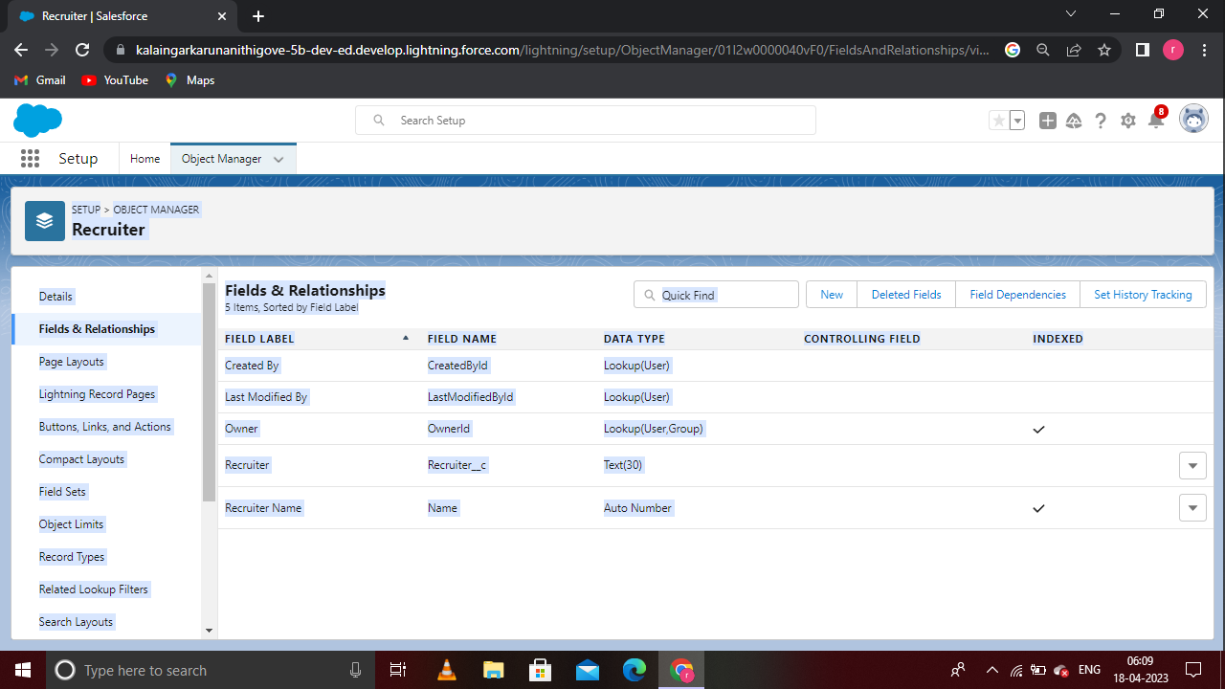

1. From setup, go to Object Manager
2. On the sidebar, click Fields& Relationship
3. Click new.

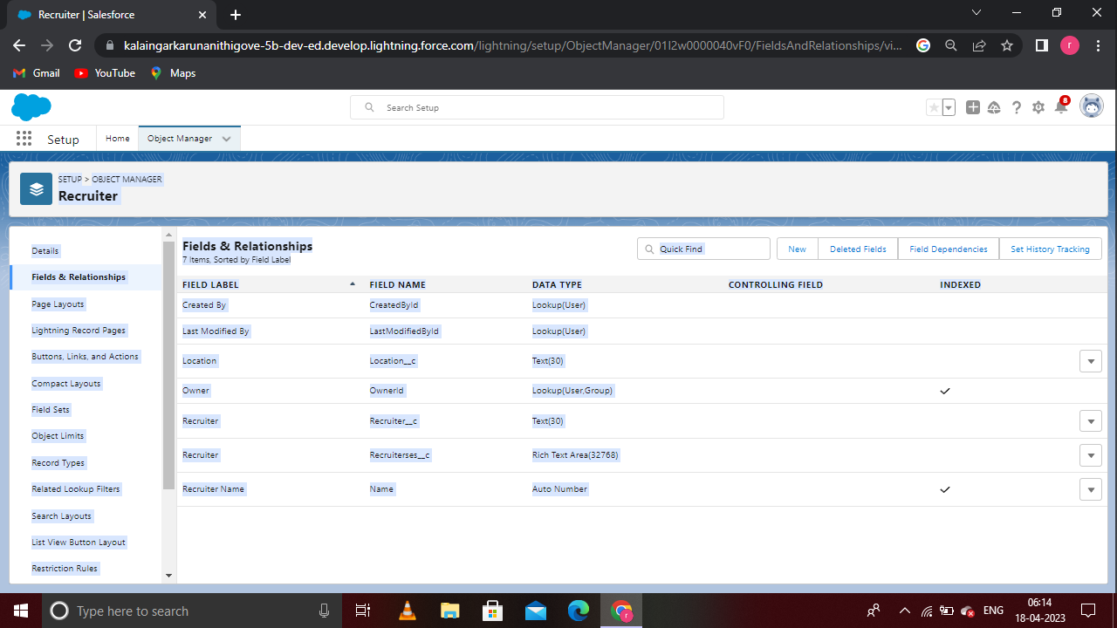

## Creation of Custom Tabs

1. Object tab Section.

2. Select the created object Recruiters and tab style for the new custom tab.

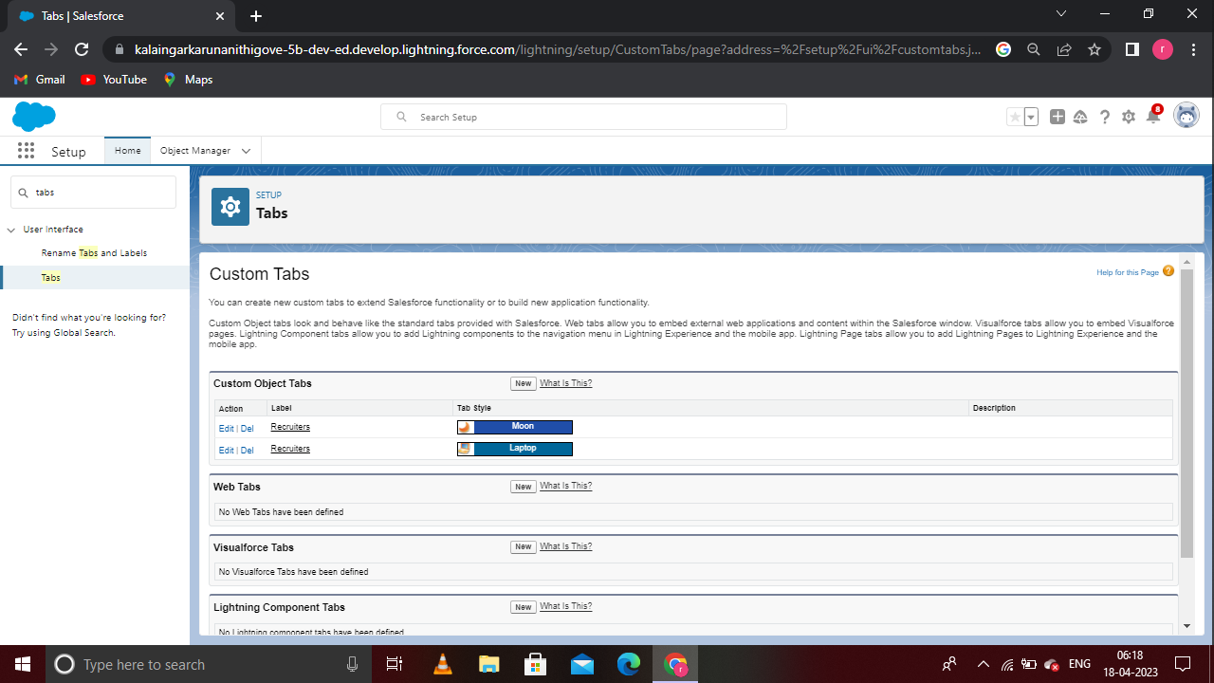

## Profile

A profile is a group/collection of settings and permission that define what a user can do in

salesforce. A profile controls Object permissions, Field permissions, User permissions, Tab

settings, App settings, Apex class access, Visual force page access, page layouts, Record types,

Login hours& Login IP ranges.

## C:\Users\ELCOT\Documents\Screenshot 2023-04-18 062149.png

## To create a User:

1 .From setup, enter Users in the Quick Find box, then Select Users.

2. Click New Users.

3. Enter the first name and last name.

4. Enter the user name and email address and a unique username in the form of an email

address.

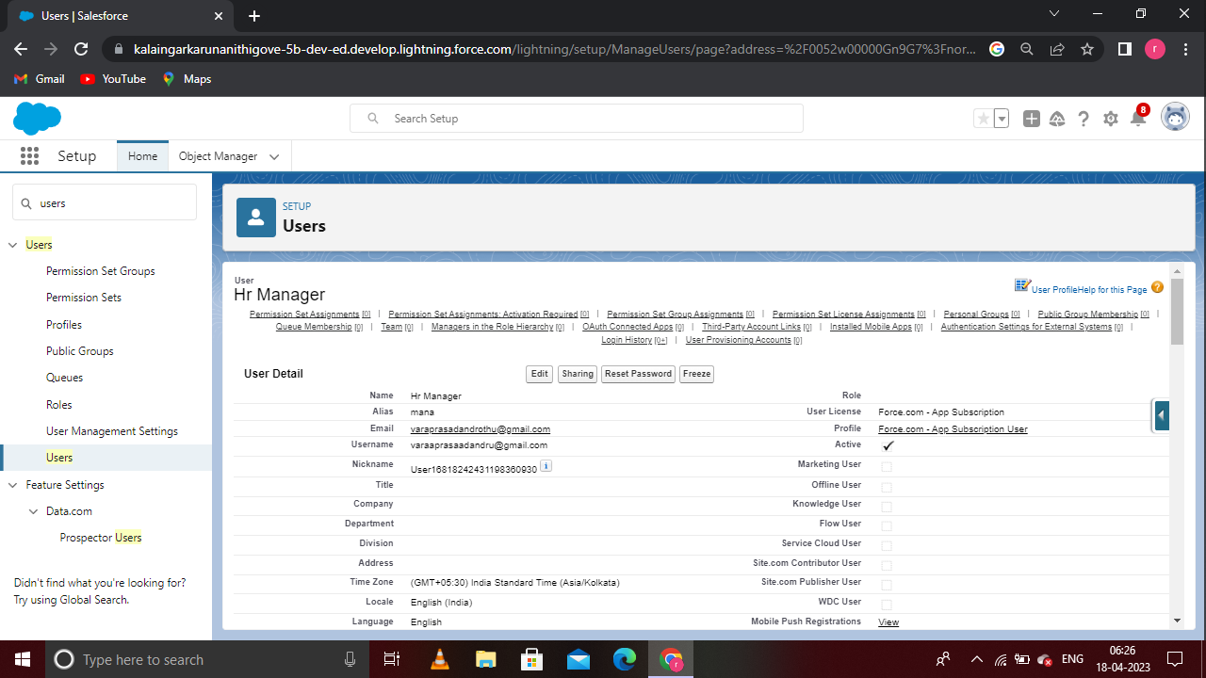

## Create the sharing rule

1. Go to sharing settings, which can be found under the quick Find section.

2. Click new to create a new sharing rule.

3. Add the label of the sharing rule you want to make.

4. Select your rule type based on the Criteria.

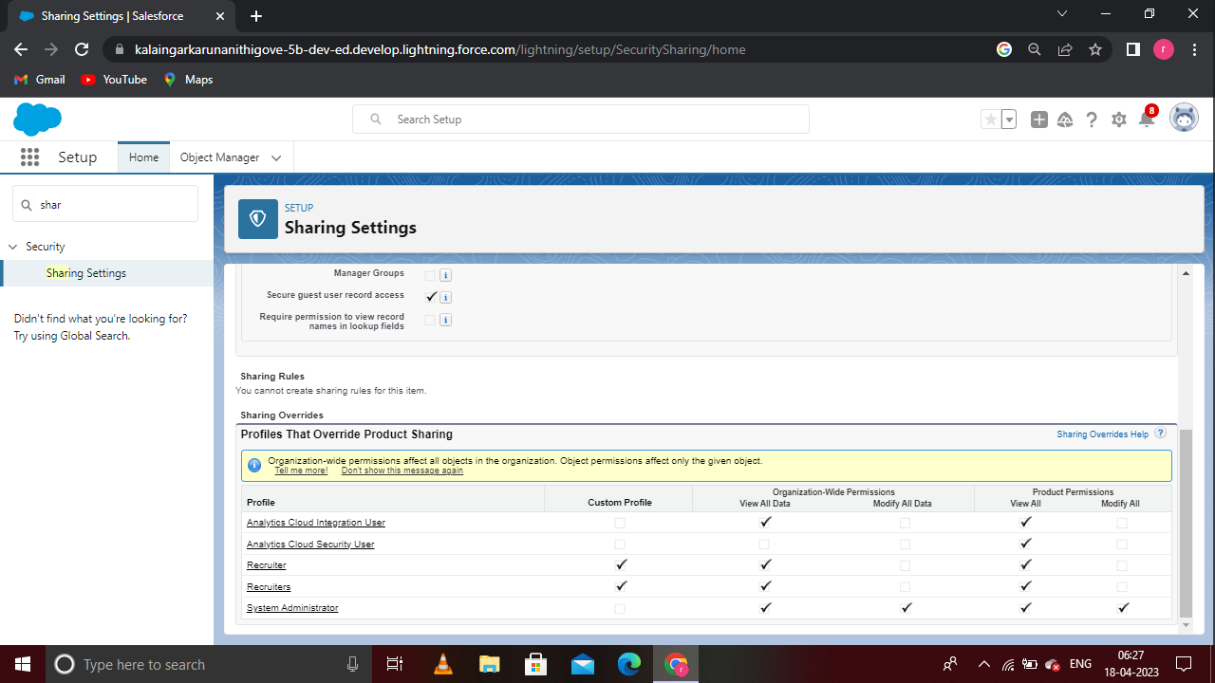

## Reports:

A report is a list of records that meet the criteria you define. It is displayed in rows and columns, and can be filtered, grouped, or displayed in a graphical chart. Every report is stored in a folder. Folders can be public, hidden, or shared, and can be set to read-only or read/write.

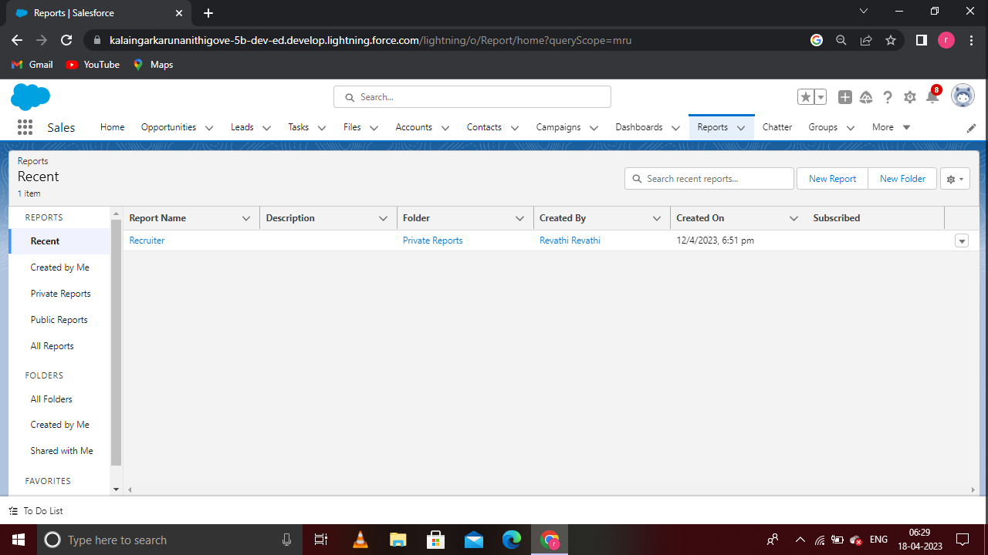

## 4. Trailhead profile public URL

Team Leader - R. Revathi : - <https://trailblazer.me/id/revar23>

Team Member 1-: S. Santhiya : -<https://trailblazer.me/id/ssugumaran6>

Team Member2- M. Saranya : - <http://trailblazer.me/id/saram340>

Team Member 3- M. Sathiyabama : - <https://trailblazer.me/id/sathm55>

## 5. ADVANTAGES & DISADVANDAGES

## List of Advantages:

Streamlined recruitment process: ATS can automate the recruitment process, from job posting to applicant screening to interview scheduling, which saves recruiters and hiring managers time and allows them to focus on more strategic tasks.

Improved candidate quality: An ATS can help recruiters quickly identify the most qualified candidates for the job by automatically filtering out unqualified candidates based on specific criteria, such as education, experience, and skills.

## List of Disadvantages:

Technical issues: Like any software system, job application tracking systems can experience technical difficulties or glitches, which can result in lost data or delayed hiring decisions.

Bias:

There is a risk of bias in the hiring process if the job application tracking system is not designed to remove certain biases or if the system is improperly configured. This could lead to discriminatory hiring practices.

## 6. APPLICATIONS

Improving candidate experience: A job application tracking system can provide candidates with a more positive experience by providing timely updates on their application status and making it easier for them to apply for open positions.

Centralizing candidate data: A job application tracking system can help organizations to collect and store candidate data in a centralized database, making it easier to track applicant progress and keep track of important information.

## 7. CONCLUSION

In conclusion, a job application tracking system can be a powerful tool for organizations to manage their recruitment process, streamline operations, and improve their hiring outcomes. While there are some potential disadvantages to these systems, such as limited customization and technical issues, the benefits can outweigh these concerns.

## 8. FUTURE SCOPE

The Job application tracking system (ATS) is a software application that streamlines and automates the recruitment process for companies. With the increasing use of technology in recruitment, the ATS has become an essential tool for HR departments in today's job market. Here are some potential future scopes of the Job application tracking system.

Integration with Artificial Intelligence (AI):

ATS can be integrated with AI to create intelligent hiring systems that can automatically filter resumes, match job requirements with candidate skills, and even conduct initial interviews.